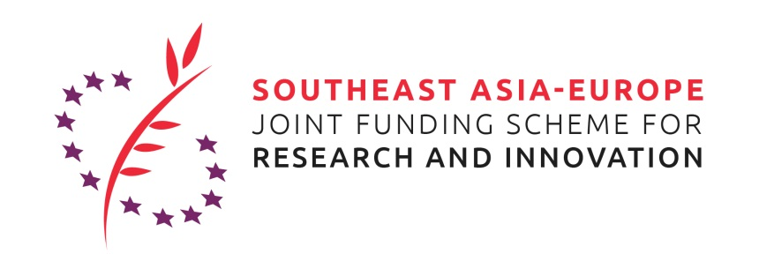

**Call for Applications:**

**Travel grant to the SEA-Europe JFS matchmaking and networking event at the** [**Bio Investment Asia 2019**](http://www.bioinvestmentasia.com/)**, Bangkok, Thailand, 25-27 September 2019**

The applicant applies for a travel grant to present his/her project idea for a **project proposal to be submitted under the 2019 Innovation Joint Call for Proposals** of the Southeast Asia – Europe Joint Funding Scheme (JFS) (<https://www.sea-eu-jfs.eu/calls> ) in the thematic area of Infectious Diseases (incl. AMR). In addition, the JFS team and partners will aim to support the organization of appointments with further potential project partners during the stay at the Bio Invest Asia 2019.

The objective of the trip and the presentation is to identify partners for a project proposal.

The thematic area is **Infectious Diseases (incl. AMR)**.

Deadline for submission of an application is **25. August 2019, 11.59 pm.**

Please note that the travel grant aims to facilitate the formation of bi-regional project consortia. Therefore, the **call is only open for researchers working at institutions in European countries that participate in the 2019 JFS Innovation Call for Proposals in the field of Infectious Diseases (Czech Republic, Spain and Turkey)**.

The applicant will be informed if he/she was selected for the travel grant on 30. August 2019. There is no legal entitlement to the grant.

The selected applicant will present his/her project idea in a 20 minutes slot at the JFS networking event on 26 September 2019, which is attached to the conference/exhibition “Bio Investment Asia 2019” in Bangkok, Thailand. The successful applicant will provide a file for a poster (DIN A0) and slides for the presentation to the organizer of the event by 20. September 2019. The successful applicant receives a non-refundable travel grant that covers the transportation from the location of his/her institution to the event, accommodation during the Bio Invest Asia 2019, a daily allowance and free entry to the event. The travel will be booked by the organizer of the event. All details about the booking will be clarified upon the information about the successful application.

To apply for the travel grant, please fill in all requested information of this form and send the **filled application form** and **your CV** by e-mail to: [sea_eu_jfs@servicefacility.eu](mailto:sea_eu_jfs@servicefacility.eu) (copy [hans.westphal@dlr.de](mailto:hans.westphal@dlr.de); adele.clausen@dlr.de ).

**Personal data of travelling person**

|  |  |
| --- | --- |
| Name, Surname: |  |
| Position: |  |
| Organisation/company: |  |
| Address (Street, postal code, town, country): |  |
| Email: |  |
| Telephone: |  |
| If applicant is a PhD-student, e-mail contact of supervisor/disciplinarian: |  |
|  |  |

*Please note that you can only apply if your organization/company is located in a European country participating in the 2019 Innovation Call (Czech Republic, Spain, Turkey).*

**Application** (max. 3 pages excl. CV)

Me:

* *Shortly introduce your background and your current position*

My institution:

* *What institution/company are you working for?*
* *What are the main (research) areas/ business fields that the institution/company is active in?*
* *What are relevant projects your institution implements or implemented in the area of Infectious Diseases (incl. AMR)?*

Our project idea:

* *What is the thematic field of your project idea and what shall be done in the project?*
* *What is the international/bi-regional (Southeast Asia - Europe) aspect of the project?*
* *What is the innovative aspect of the project?*
* *Did you already identify other partners for the consortium? If yes, who are they?*
* *What would be your institution’s/company’s contribution to the project? What would be the contribution of other identified partners?*

Your participation:

* *What kind of partners are you still looking for? What type of organization/company, what expertise? What could be the partner’s contribution to the project?*

**CV**

**Please attach your CV to the application!**